Hands-on Exercise No. 4
DigiSkills 3.0 Batch-04
Data Analytics and Business Intelligence

Task:

Question No : 1 Create Card visuals to display the following key performance indicators (KPIs):
• Total Orders
• Total Revenue
• Total Sales

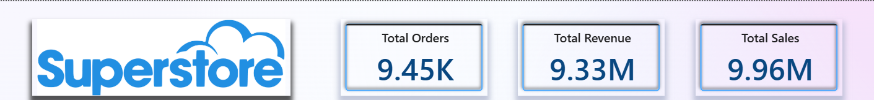

Question No : 2 Create a Line Chart to visualize the Monthly Sales Trend. Display Sales on the Y-axis and
Order Date on the X-axis.

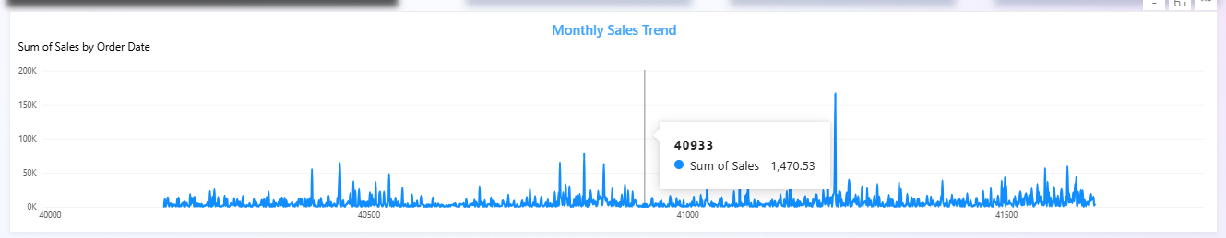

Question No : 3 Create a Donut Chart to display the Total Sales by Category. Show data labels to display each segment's percentage contribution to the total sales.

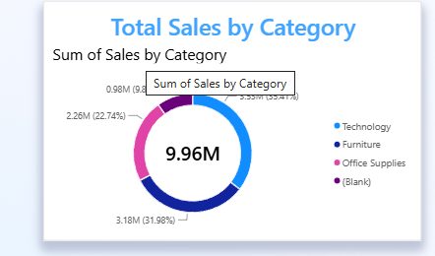

Question No : 4 Create a TreeMap to visualize the Total Sales by Sub-Category.

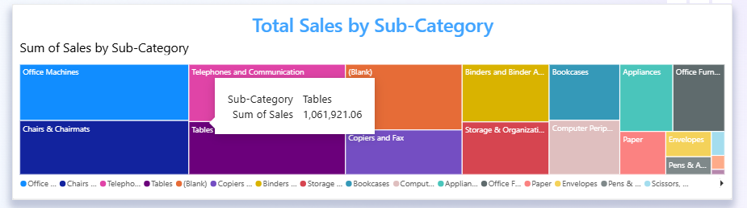

Question No : 5 Add Slicers for the following fields to make the dashboard interactive:
• Customer Segment
• Region

Question No : 6 Arrange all the visuals created in Questions 1 to 5 on a single Power BI page named "Executive Dashboard". Apply an attractive theme and organize the visuals to create a professional, easy
to-read dashboard suitable for executive-level reporting.
